First Responders Tracker: 5G Tracking Inside and Out

CS 4643.001

Dale Graham, Jina Wilde, Raisul Islam, Samantha Ramos

1. ABSTRACT

**Jina:**

The purpose of this report is to detail the First Responder Tracker system concept. Research on prior arts and latest commercial and government developments is gathered and synthesized to propose improvements to aid first responders and military in dangerous environments and events. Results show there is much potential with 5 and eventually 6G networks with the increase in data speed transmission to give real-time analytics. Partnering with the government’s First Responder Network Authority (FirstNet) and companies like AT&T can aid in real solutions to difficult problems facing first responders.

1. INTRODUCTION

**Jina:**

First responders and military personnel can work in dangerous environments where they may be exposed to hazardous chemicals, smoke-filled areas where there is difficulty seeing and breathing, and other situations which may expose them to bombs and land mines. 5G technology will assess the scene before, during, and after emergency or dangerous events to assist first responders with real-time sensor and GPS mapping data, communications, and other tools like drones. Before going into buildings on fire, for example, temperature sensors, carbon monoxide and smoke detectors, and cameras can transmit data to see what is happening. If the ceiling is collapsing or the air is not breathable, first responders can make informed decisions. During emergency events, location signals and sensor data can be relayed in real-time to keep track of their movements and environment. After emergency events, first responders will be able to get additional information such as traffic conditions for ambulances going to the hospital. The tracking systems will also have features that can be deployed for military use.

The First Responder Tracker system is the proposed solution to help. The market segment targets will be the federal government with the National Guard, military, and First Responder Network Authority (FirstNet), and local governments with first responders. Monetization will focus on these target audiences. Features will include mobile applications with multi-gas sensor detection readings, mapping indoors with thermal viewing, real-time traffic updates, and even landmine detection with drones, cameras, sensors, and robotic attachments. Landmine detection will be for military use and would require extensive cybersecurity analysis when deployed in non-U.S. territories due to the sensitive nature of the activity.

Prior arts research includes several key technologies. The FirstNet system is run separately from public cell phone towers, and is dedicated only to first responders. First Net uses the Distributed Antenna Systems (DAS) where large concrete and steel structures limit indoor cellular coverage. The DAS network has over 6,000 networks of small antennas that enhance wireless services that networks typically do not reach. [6]. For consumers who do not have access to the FirstNet system, commercial technologies and research has potential to aid first responders also. Indoor and outdoor mapping with GPS, ultra wideband, or Wi-Vi, thermal cameras and other sensors, drones, and application development are being developed, but there is a lot of work that can be done to increase their use.

1. DISCUSSION
2. *Architecture Diagrams*

**Dale:**

The First Responder Tracker will use the latest network technology to assist first responders in dangerous situations and one of the ways to do this is by making use of a 5G network. To make use of a 5G network a 5G network architecture will need to be employed and an important part of this architecture is the 5G core. And the 5G core that will be used by the First Responder Tracker is one that will cover all 5G network functions. The 5G core is defined by the 3GPP and makes use of a cloud-aligned and service based architecture that covers all of the 5G interactions and functions [1]. These functions include session management, aggregation of traffic from end devices, security, and authentication [1]. The 5G core also features network function virtualization as an essential component with these functions being deployed with multi-edge computing infrastructure as part of the 5G architecture [1]. The 5G network will also be deployed as a stand alone model. The 5G network also aims to have some of the same functionality as the FirstNet network. And it also aims to have extended coverage by having 5G connectivity enabled by satellites and drones.

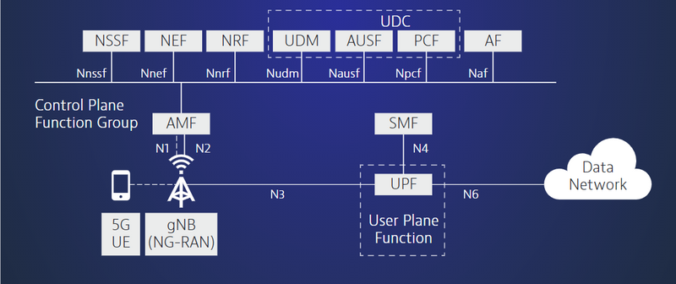 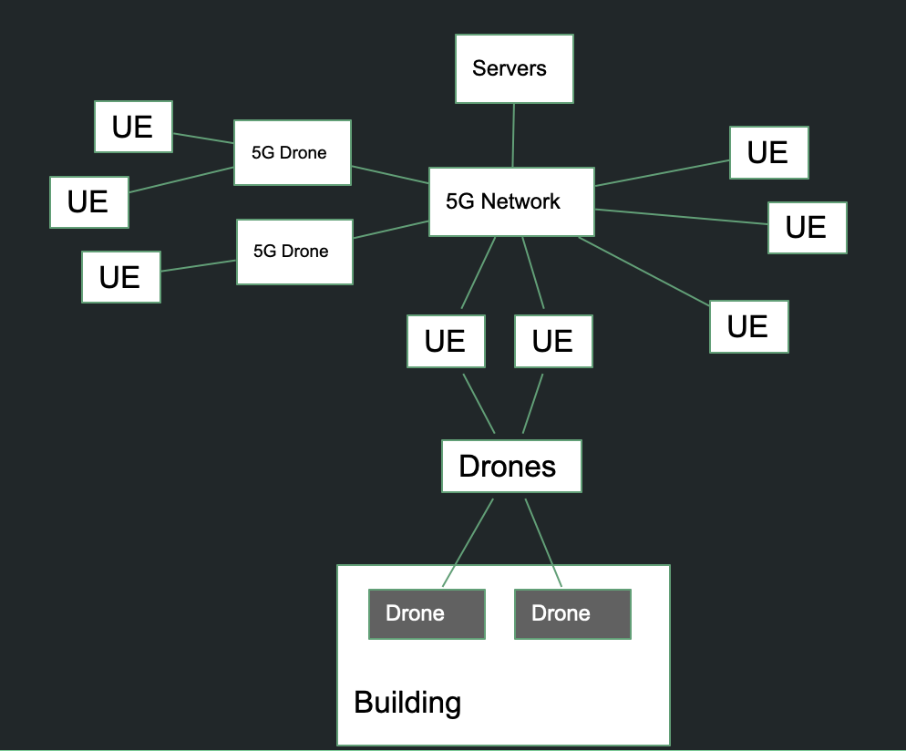

Image Source: <https://www.viavisolutions.com/en-us/5g-architecture#:~:text=5G%20Core%20Architecture&text=The%20new%205G%20core%2C%20as,of%20traffic%20from%20end%20devices>.

(Figure 1) (Figure 2)

The above figures show both the 5G network core and an example of a 5G network that the First Responder Tracker would deploy. For the 5G network core, figure 1 shows the architecture of the 5G network core. In the 5G core architecture, user equipment (or UE) connects to the control plane function group and the user plane function through the 5G radio access network, which is known as the gNB and NG-RAN, and further to other data networks such as the internet [2]. Additionally, the Access and Mobility Management Function (or AMF) in the 5G core acts as the point of entry for the UE [2]. And the Session Management Function in the 5G core will manage the user’s session [2]. The Authentication Server Function (or AUSF) enables UE to be authenticated by the AMF and thus able to access the services of the 5G core [2]. Further, the User Plane Function (or UPF) enables the flow of IP traffic to and from the UE and external networks [2]. Other 5G core functions like the Policy Control Function, the Application Function, and the Unified Data Management function are responsible for things such as providing the policy control framework and applying policy decisions to govern the 5G network behavior [2].

In figure 2 an example of a 5G network that the First Responder Tracker would deploy is given. In the figure it can be noted that data flows to and from the servers of the First Responder Tracker and first responders out in the field by means of the 5G network. For instance, figure 2 shows the flow of data from drones that can be both inside and outside of a building, to user equipment on the ground outside of the building, through the 5G network, and then to the servers of the First Responder Tracker. Figure 2 also shows how 5G connected drones can extend 5G network coverage to first responders that are further out in the field. In the figure, it shows the data flow to and from the user equipment in the field, through the 5G connected drones, through a 5G network, and then the First Responder Tracker servers. The figure also shows a simple scenario in which data flows to and from the servers of the First Responder Tracker, through the 5G network, and the user equipment of first responders out in the field. The 5G network that figure 2 uses is one that uses and has the same functionality as the 5G core architecture that is seen in figure 1.

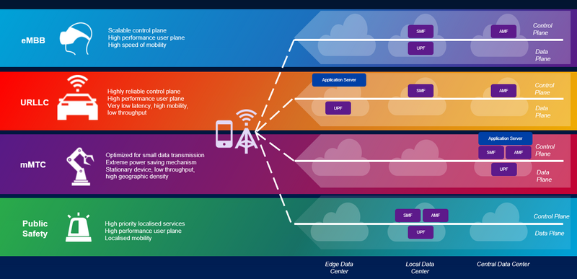

Image Source: https://www.viavisolutions.com/en-us/5g-network-slicing

The above image shows 5G network slicing which would be an important part of First Responder Tracker’s deployed network in order to guarantee first responders the high-speed connections that they need. 5G network slicing allows for networks to be customized and this allows for multiple logical slices of network functionality that are optimized for specific application requirements [2]. An example of this is that a 5G network operator can offer a network slice that is customized for high bandwidth applications, a slice that is tailored for low latency, and a slice that is optimized for a large number of IoT devices [2]. Further, some 5G core functions may not be available depending on the slice [2]. And since not every network slice needs the same capabilities, the network’s computing power can be used more efficiently [2]. An example usage of the network slicing functionality for the First Responder Tracker can be seen in the above image in which a network slice is provided for public safety purposes. This means that the necessary functionality and bandwidth that first responders using the First Responder Tracker need can be guaranteed to them. And since 5G network slicing allows for a network’s computing power to be used more efficiently, more bandwidth and functionality could be allocated to public safety purposes for first responders during times of crisis.

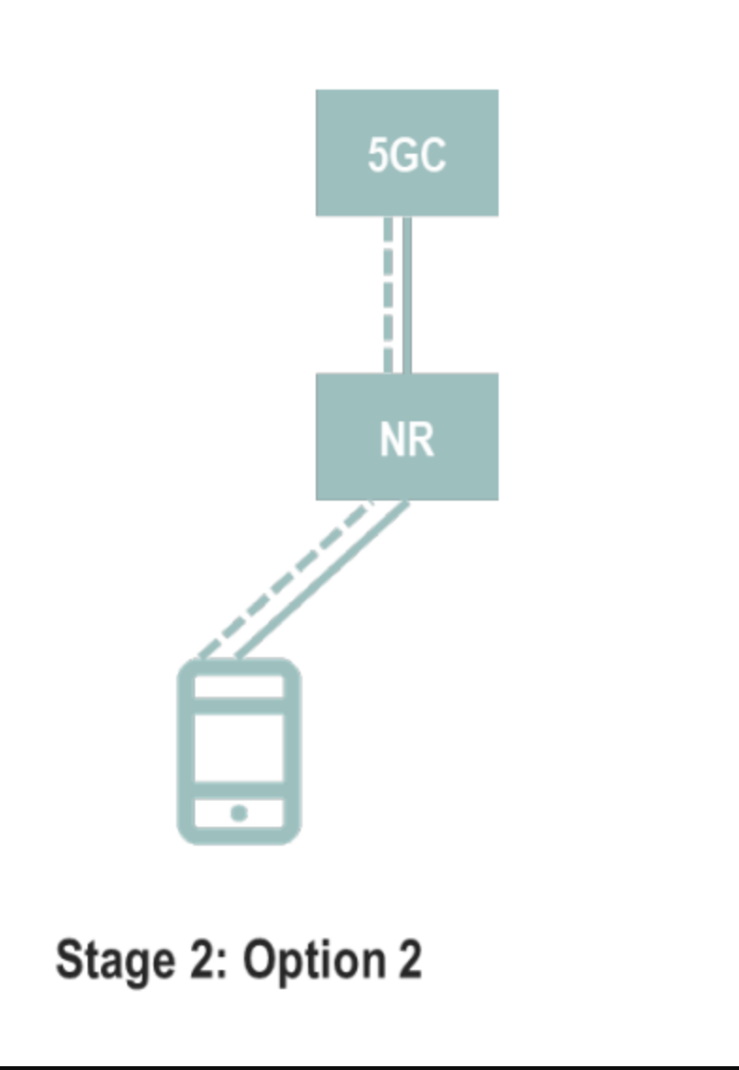

Image Source: https://www.gsma.com/futurenetworks/wp-content/uploads/2020/06/5G-SA-Option-2-ImplementationGuideline-v1.3.pdf

The above image shows the 5G network deployment option that the First Responder Tracker will use. The image shows the stand-alone option for the 5G network. The stand-alone option for a 5G network will provide the full benefits of a 5G network such as low latency, a large amount of bandwidth, and the ability to connect many IoT devices [2]. For instance, 5G stand-alone option 2 can enable live streaming of high-definition video with 1 Gbps or more downstream and 200-300 Mbps upstream data rates [3]. Additionally, the stand-alone option 2 can better fulfill stringent and service critical requirements which includes latency, reliability, security, and real-time capabilities [3]. Further, the 5G stand-alone option 2 provides benefits in edge computing which reduces the latency experienced by users. The First Responder Tracker will aim to take advantage of the benefits provided by the 5G stand-alone option 2. This is because the advantages provided by option 2 in the areas of bandwidth and latency will help in the flow of information. This will benefit the First Responder Tracker since the high speeds and large amounts of bandwidth will allow it to deliver and receive information to and from first responders in a timely fashion.

1. *SIP/SDP call flows*

**Dale:**

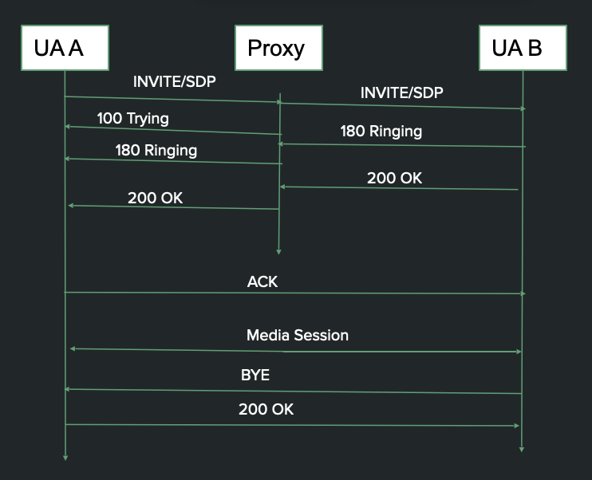

The above image shows a basic SIP/SDP call flow that the First Responder Tracker will make use of. The SIP/SDP call flow establishes communications or multimedia sessions between first responders. In the image, a user agent attempts to establish a connection with another user agent through a proxy. More specifically, user agent A sends an INVITE/SDP to the proxy which then sends the INVITE/SDP to user agent B. User agent B then responds with a 180 Ringing and a 200 OK to the proxy which then sends both to user agent A. After this, user agent A then sends an ACK to user agent B. Once successful a media session then takes place between the two user agents. And after this user agent B sends a BYE to user agent A who then responds with a 200 OK. A proxy-based SIP/SDP call flow was chosen because a proxy enables additional features such as database queries, services such as forwarding, and can be stateful in terms of transaction or calls. Additionally, the First Responder Tracker will use the SIP protocol with TCP. This is because TCP allows for features such as congestion control, flow control, and for TLS to be easily implemented.

1. *Hardware Equipment*

**Jina:**

In remote and extreme settings, 5G may not be available, especially in global combat zones. FirstNet has satellite solutions through Inmarsat Government Satellite phones and transportable broadband devices that can expand network capabilities [6]. The Inmarsat Government agency provides satellite communication services to the U.S. government that can reach almost any location on the planet, including remote, wartime, rural, or disaster/emergency-affected areas [9]. When using satellite phones, there is additional latency, however satellite communication services are very easy to use and have global coverage. Inmarsat’s Broadband Global Area Network can be set up in minutes with its laptop-size, portable antennas and can be mounted on platforms including vehicles and boats as the user moves around [17]. The figures below show the FirstNet satellite coverage available with Inmarsat and transmitting devices.

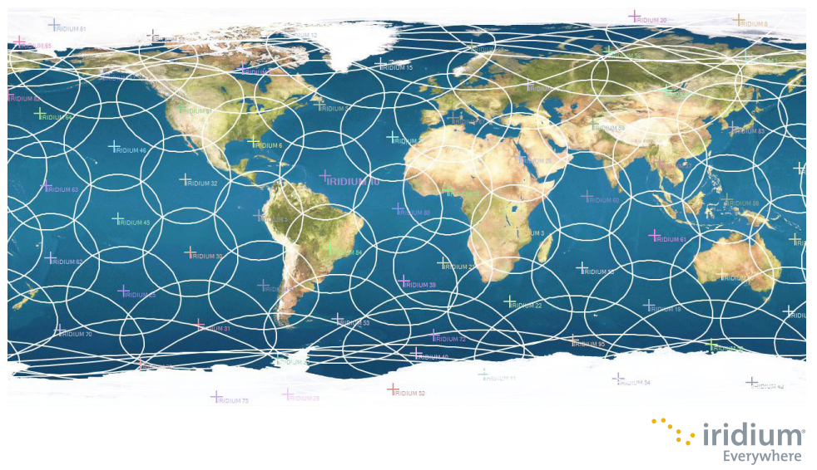 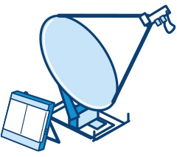 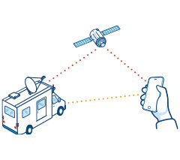

Image Sources: <https://www.inmarsatgov.com/firstnet/wp-content/uploads/2020/03/iridium-coverage-map.pdf>, <https://www.inmarsatgov.com/firstnet/satellite-faq/#coverage>

For first responders who do not have access to the FirstNet system, TrackIO is a research project that tested optimal ways to create indoor maps and ways of tracking people inside of large buildings. TrackIO researchers found ultra-wideband (UWB) radio technology to show the best results for creating maps indoors. Geo-tagging and video streaming with drones, phones, or other connected devices were able to display the GPS coordinates which could be shared in real-time to give location data. Ultra-wideband imaging gives users the ability to see heat sources such as people behind walls and doors, which is another way to improve visibility as demonstrated in the figure below [15].

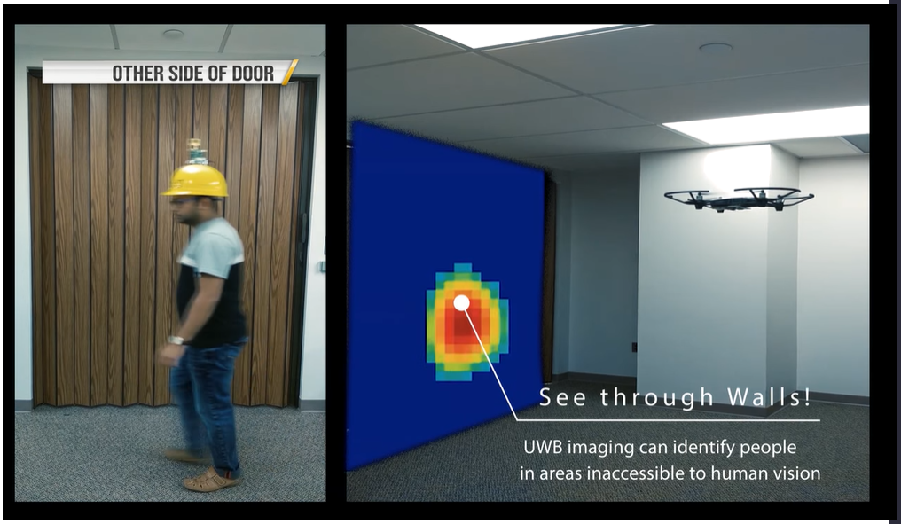

TrackIO’s research is evolving to NavigateIO. The figure below of NavigateIO Operation shows a simple diagram of the devices (beacons) that first responders would use, connecting to an anchor and controller and displaying information on a graphical user interface [16].

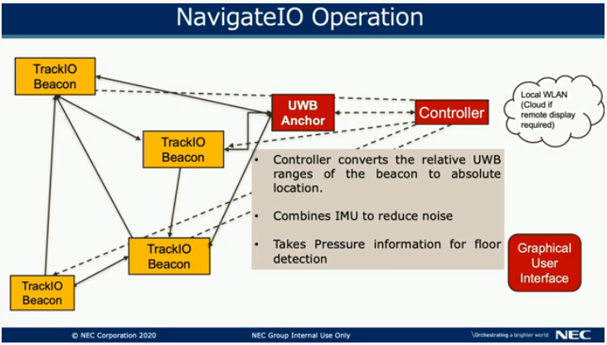

**Raisul:**

There might be a question about what we will use if we won't be able to send a drone or if there is no sensor device inside a collapsed building how we will use this technology.

We can use WI-VI technology with the help of a 5g network [8]. Wi-Fi signals are usually used to transport data between a sender and a receiver. These signals can also enhance our bits of intelligence, allowing us to perceive objects that are found moving through the walls and behind closed doors. These signals may be used to determine the number of individuals in a room as well as their virtual placements. We can also recognize basic movements performed behind a wall and arrange them in order to send messages without having to carry and transmit equipment to a wireless receiver. Seeing behind the wall is a fantasy that many people desire to have. We want people to know it is possible. Let's find out how it can be more beneficial with the help of 5g technology.

• This technology is much needed and valuable for law enforcement to prevent stepping into an ambush and reduce death in stalemates and criminal activities.

• Rescue workers may use it to understand ruins and fallen constructions.

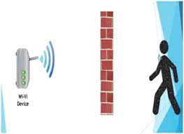

Wi-Vi is effectively a three-radar device that uses a MIMO interface with double antennas, one for transmitting the data and the other one for receiving. Another directional antenna sends the energy to the desired area or wall.

Its design consists of two key elements:

1. The first element reduces the flash reflected off the wall by performing MIMO nulling.
2. The second element follows a moving object by considering the item as an antenna array using an inverse ISAR approach.

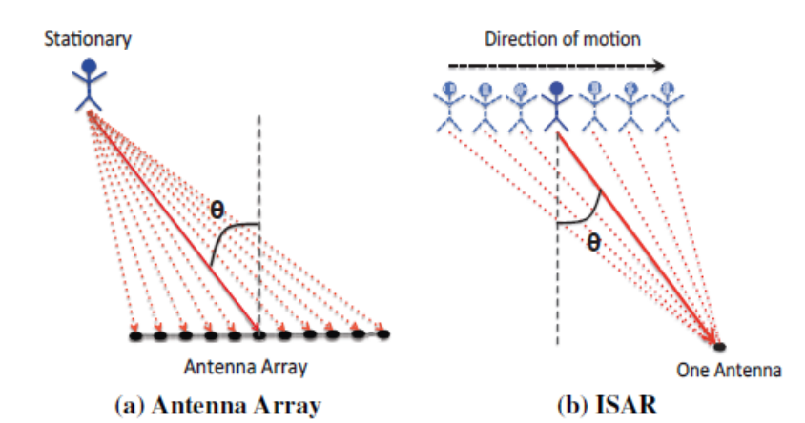

Existing antenna array systems catch the signal reflected off a target from regionally dispersed antennas and analyze it to determine the target's orientation in relation to the array. ISAR or Inverse Synthetic Aperture Radar has only one receiving antenna; therefore, the receiver only takes a single measurement at any moment. When the object travels, it reacts as the signal is received at different positions, as if each of these sites had a receiving antenna. Wi-Vi receives sequential time samples that match consecutive three-dimensional positions of the moving object due to channel reciprocity. Therefore, Wi-Vi practically gets whatever an antenna array receives in space in real-time. The project is about Wi-Fi, a wireless system that is designed to detect moving entities behind the walls or in confined places using signals. Unlike prior systems, which were aimed at the armed services, it allows for a small and low-cost device that can help people see-through walls to function in the ISM band, to make them accessible to people. This technology develops a channel to communicate between the device and a human moving across the wall. It also allows humans to communicate with Wi-Vi without the need for a piece of transmitting equipment or device. Wi-Fi inspires a new type of user interface that identifies human motions purely through the images of an RF signal transmitted. By combining finer nulling techniques with improved technology, the system can see people through thicker structures or materials and from a long distance. Such enhancements will allow for the collection of higher-quality photos, which makes the gesture-based interface more communicative, perhaps opening new computer-generated reality options.

In mathematical form,

Let y (n) be the sampled signal that the Wi-Vi receives at discrete point n. Let θ be the spatial angle that connects the human to the Wi-Vi and also the normal to the motion.

A [θ, n] is a function that measures a signal along the spatial direction.

To find A [θ, n]:

It processes the received samples, which remove the effect of the transmitted signal.

h (n) = y (n)/x (n).

To emulate the antenna array, Wi-Vi uses w consecutive channel measurements h[n]…..h [n+w].

A[θ, n] is computed.

The θ value, which produces the highest value in A [θ, n] indicates the direction in which the target is moving.

Here Δ = vT, where T represents the sampling time period.

The first benefit is that this system only uses one receiver and still successfully measures the time it receives for the signals to reflect to analyze the exact location. The second is that low-cost Wi-Fi technology systems can be used in disaster recovery. And lastly, Wi-Vi technology, as a gesture-based interface, does not need a line of sight between the user and the device.

**Jina:**

Land mine detection is another area of emerging research and development. The Mine Kafon Drone has been field-tested with the Dutch Ministry of Defence [14]. A drone that is designed to map an area that has land mines, detect and then detonate them was originally designed by Massoud Hassani after growing up as a child in Afghanistan where there are an estimated 10 million mines that he said, “becomes like a mental disorder… The fear is on your mind all the time.” Drones are found to be safer and less expensive than other methods. The Mine Kafon Drone team is currently working on optimizing the drone and creating base stations. Their technology uses cameras, GPS, computers, metal detectors with sensors and a robotic arm attached as shown in the figure below to locate and safely detonate land mines.

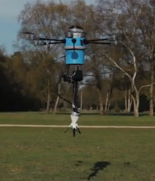

Image source: <https://www.theverge.com/2016/7/19/12222104/landmine-detecting-drone-mine-kafon-drone>

The drone places a detonator on the mine and retreats to a safe distance before it is detonated. Some of the noted challenges include GPS precision is not completely reliable and outdoor conditions and weathering makes detection harder when mines have been buried for a long period of time. Algorithms for mining detection are still underdeveloped, and there are cybersecurity concerns when using 5G in non-U.S. countries [19].

**Dale:**

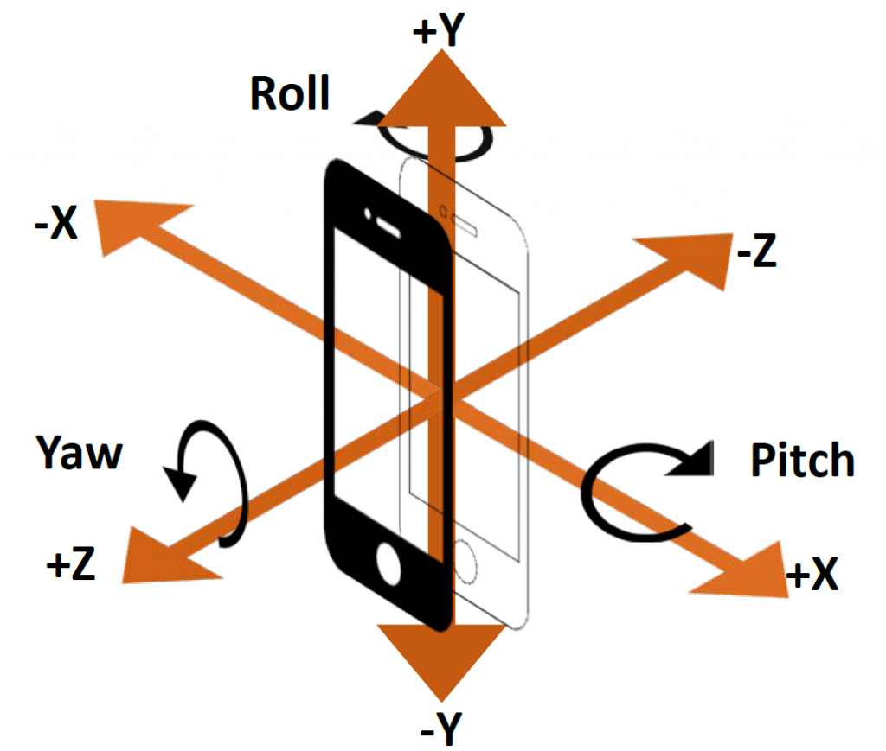

Image Source: <https://blogs.sas.com/content/sgf/2018/09/26/accelerometer-driving-profile/>

The ActivitySensor research paper has applications for the First Responder Tracker since it helps to address the problems of determining what types of activities a person may be engaged in [12]. The paper showed that this could be done by using commercially available technologies. In particular, the authors of the paper used cell phone accelerometers to conduct experiments and collect data on 29 individuals. This data was then used to train predictive models to perform activity recognition on the activities of walking, jogging, climbing stairs, sitting, and standing. These models had varying degrees of accuracy, with the multilayer perceptron an overall accuracy of 91.7%. This technology and its applications have relevance to the First Responder Tracker since the technology can be used to aid first responders. As an example, this type of information could be used to see more clearly what is happening to first responders inside of a building. And this would aid in improving outcomes for first responders. So, the First Responder Tracker will then employ an activity recognition system in order to help determine what is happening to and keep track of first responders.

**Samantha:**

A necessary technology is the 5G mini-UAV drones equipped with 5G connectivity to allow first responders the chance to assess the conditions of the scene and determine the hazards and threats. The images below show an example of the mini drone and the fire-resistant container for the mini drones.

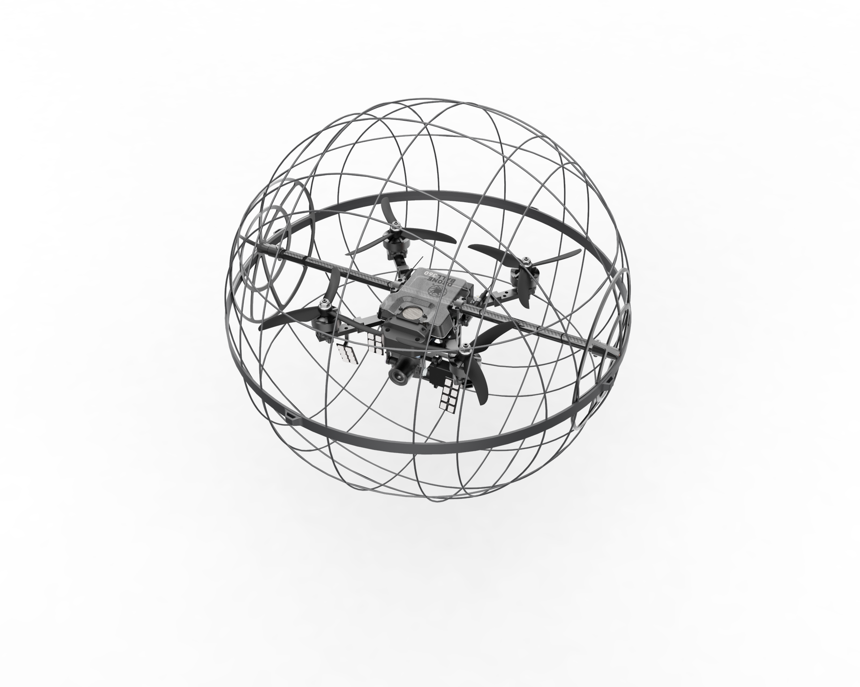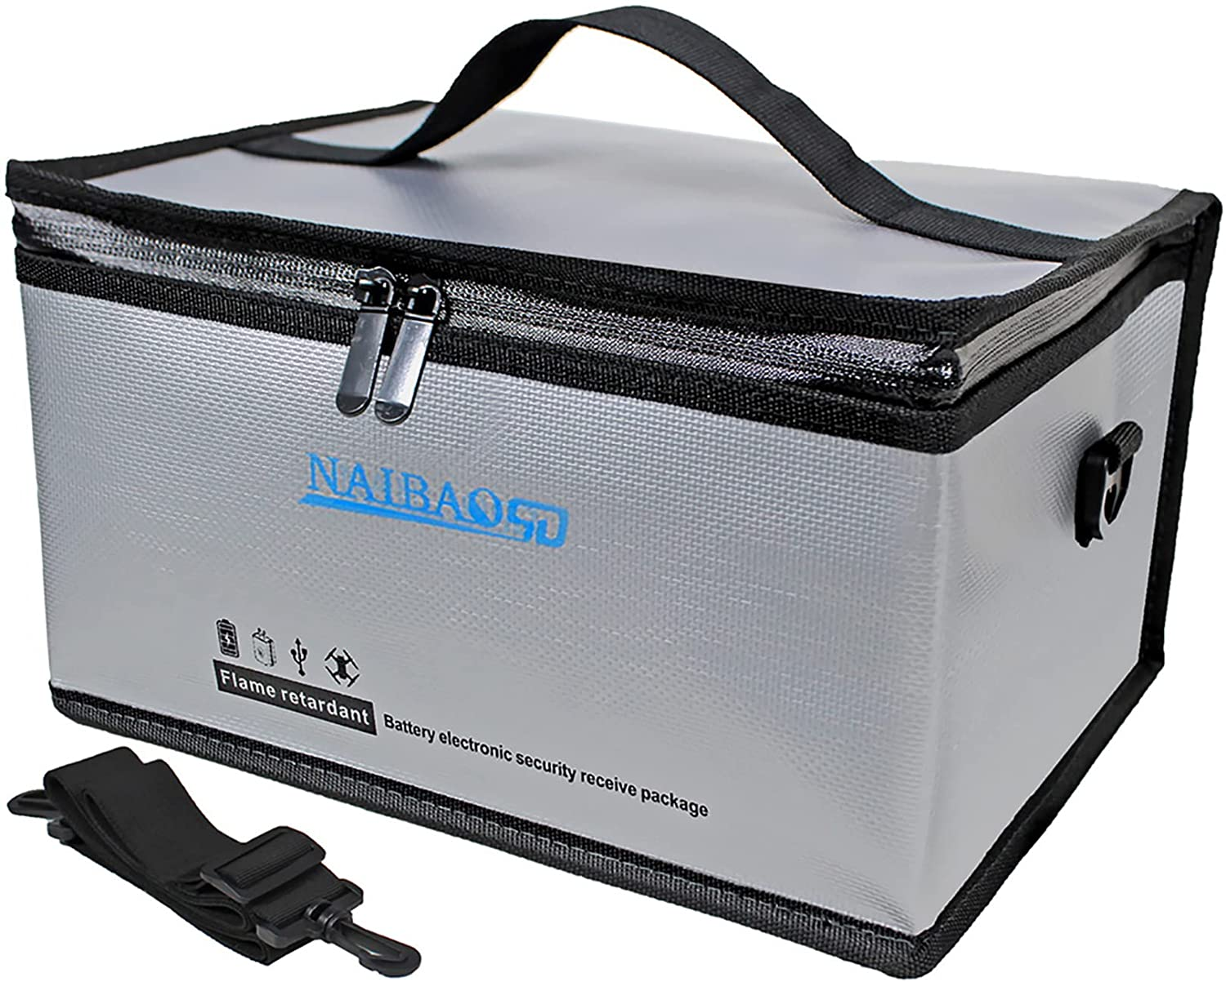

Once released from the housed container, the drones will provide the layout inside the building including thermal view, the amount of smoke, chemical vapors, and temperature. The drones will be able to provide this information by using UnLoc sensory signatures, thermal sensors, and electrochemical sensors along with a combined array of sensors including gyros, magnetometers, and accelerometers with a GPS. Included in this is flight control CPUs that are able to use the data on the attitude, velocity, position and heading of the UAV to direct the flight and operation of the drone according to the parameters.

The main sensor that will build the layout of the building is the UnLoc sensors [11]. These sensors will use Wi-Fi and magnetic fluctuations for use as landmarks to create an indoor layout of the building. The drone will be able to listen to one set of Wi-Fi hotspots and a particular point may experience unusual magnetic fluctuations; microphones and magnetometers can detect ambient sounds and magnetic vibrations. The signatures may reside in a magnetic region where metals at a particular location can produce unique and reproducible vibrations on a drone’s magnetometer near that location

The figure below shows an example of how the Unloc sensor technology works.

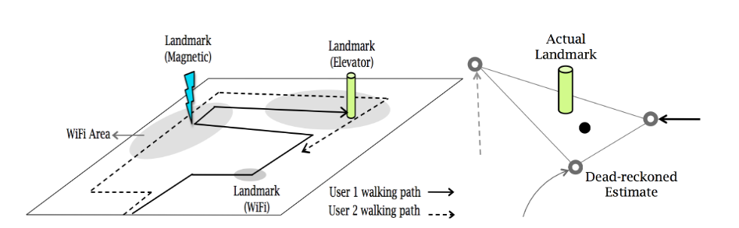

These signatures are considered as internal building landmarks. The landmarks are, in fact, some structures in the building, stairs, elevators, entrances that behave in a predictable way. This predictable behavior can be translated into sensor signatures. Drones detecting these landmarks can recalibrate their position, and then can track them between landmarks. The system simultaneously calculates the drone's positions and landmarks.

As the drones are putting together the layout, the other sensors will also be active and calculating the necessary data to provide the GUI with real-time analysis and live video footage. The thermal sensor will provide the thermal imaging and infrared radiation to see through smoke. In order for this to work, the drones will utilize a single-chip millimeter wave radar coupled with thermal cameras to allow the drones to see through low visibility. The thermal sensors will allow the infrared radiation to pass through even as the smoke particles block the visible light.

The image below shows the view that will be provided to the GUI from the UnLoc and thermal sensors.

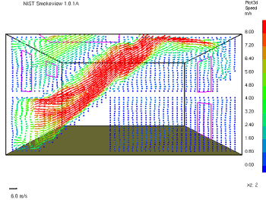 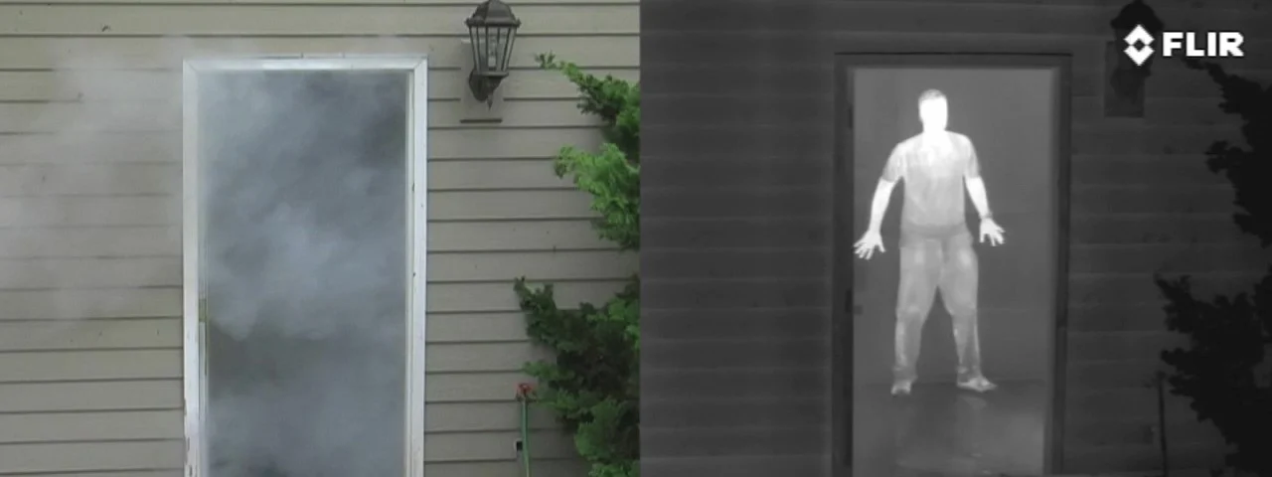

Along with the thermal sensor there is also the electrochemical sensor. The electrochemical sensor will detect various gasses such as carbon monoxide, nitrogen dioxide, hydrogen sulfide, sulfur dioxide, and ammonia. This sensor will be useful in letting first responders understand the surrounding gasses and, even after the fire is suppressed, it will let the firefighters know when it is safe to remove masks dependent on the remaining levels of toxic air. This information will also allow firefighters to know the amount of dangerous chemicals they are exposed to and keep records for medical reasons to ensure the first responder isn’t exceeding the amount that is safely recommended. The remaining sensors will be utilized for auto-pilot flight that are typically found in UAV drones and those include gyros, magnetometers, and accelerometers.

*D. Graphical User Interface Prototype*

**Samantha:**

Each of the sensors on the drone will provide the data to help firefighters make decisions and have live view from the outside before ever entering the building. This high volume of data will be analyzed in real-time and processed for immediate viewing on the graphical user interface (GUI). The GUI will include the real-time analysis, first responder tracking, live video footage, and layout of the building. As shown in the image below, the home screen of the GUI will immediately take you to the live video footage, the links to the responder’s location, the link to view the thermal and electrochemical sensor analysis, and different floor views if applicable.

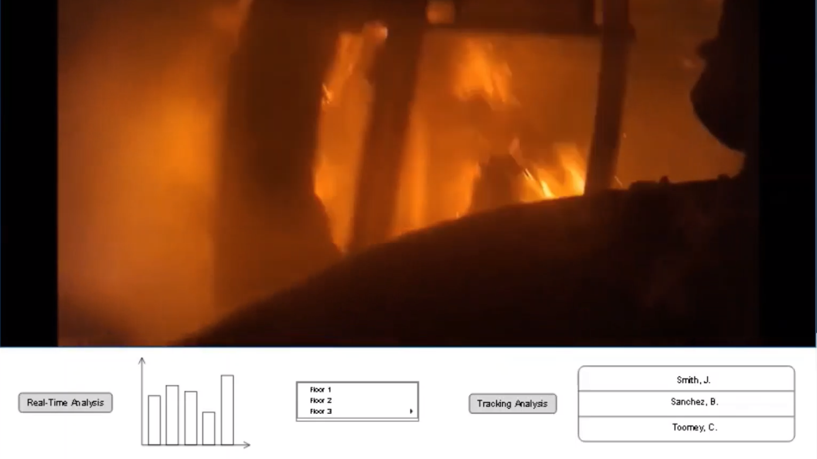

The individual first responder tracking, once a person is selected, will show each person’s location inside or outside the building, the camera feed from the person, the temperature surrounding the firefighter, and the toxic air levels. Selecting the real-time analysis option will show the gas and temperature levels combined from each drone’s electrochemical sensors to allow for assessment of the situation. The thermal view option will utilize the data from the thermal sensors, UnLoc sensors, and camera to show different views from the inside of the building. Each view will show the thermal view to see the amount of fire and a low dense view to see through the smoke. Those views will include an option to see each floor as whole or each room individually.

The sample demonstration of the GUI can be found following the link below.

<https://youtu.be/kmizSvZMxwA>

*E. Extended Features based on 6G*

**Dale:**

The First Responder Tracker will employ 6G technologies for even faster connections, data processing and reduced latency. Since 6G will bring network speeds up to 1000 times faster than 5G and even lower latency, the First Responder Tracker will benefit greatly from 6G. This is because the First Responder Tracker depends on high-speed connections to deliver critical information in a timely fashion. This information includes data such as information collected from sensors and information on the situational status of first responders inside of a building. 6G’s high speed connections, low latency, and large amounts of bandwidth will significantly improve both of those situations described by making the flow of information even faster. This will enable the First Responder Tracker’s servers’ ability to receive and process data and deliver it back to first responders out in the field to be faster. 6G will also enable the First Responder Tracker to be more accurate since the low latency and high speeds of 6G will allow first responders to receive data and information that is nearly in real time with 6G’s latency being around 1 ms. Therefore, due to the above-mentioned benefits in speed and latency, the First Responder Tracker will aim to take advantage of 6G technologies when available.

IV. LEARNING EXPERIENCE AND RESULTS

**Jina:**

Innovative research using 5G shows the potential and opportunities in developing products to aid first responders and the military in dangerous situations. Thermal sensors using ultra-wideband or Wi-Vi technology, chemical sensors to detect smog, oxygen or carbon dioxide levels, cameras on drones with robotic arms may help detonate landmines, indoor mapping, GPS, traffic data, and tapping into the FirstNet network can be a holistic system.

V. CONCLUSIONS

**Dale:**

This report has described how the First Responder Tracker works and what it aims to provide first responders who are out engaged in various activities. The report has shown the 5G network architecture that the First Responder Tracker will employ and how 5G coverage could be extended via satellites. This report has also described the technologies that the First Responder Tracker will use. Some of these technologies include UAV drones, accelerometers, and Wi-Vi. The Report also described the added benefits that 6G the First Responder Tracker will provide in terms of high-speed connections and latency. And the First Responder Tracker will aim to add these extended benefits from 6G when available in the future.

VI. RECOMMENDATIONS

**Jina:**

Recommendations for the First Responder Tracker system is to continue integrating sensor and data readings into devices that can give real-time feedback almost immediately. Many of these technologies are still in testing and development, but tests are promising. Application development is still needed to increase quality and competitiveness for most of these applications. Further successful implementation for the First Responders Tracker will be available as 5G and 6G is rolled out, however there are security concerns that will hinder international rollout such as in war zones or other hostile countries. In the U.S. there can be substantial benefits to first responders and the military with tracking and data information available with 5G.

VII. REFERENCES

**Dale:**

[1] “5G network architecture. core, ran, & security architecture for 5G,” 5G Network Architecture. Core, RAN, & Security Architecture For 5G, 12-Jan-2022. [Online]. Available: https://www.viavisolutions.com/en-us/5g-architecture#:~:text=5G%20Core%20Architecture&text=The%20new%205G%20core%2C%20as,of%20traffic%20from%20end%20devices. [Accessed: 19-Apr-2022].

[2] H. Remmert, “What is 5G network architecture?,” *Digi International*, 19-Mar-2021. [Online]. Available: https://www.digi.com/blog/post/5g-network-architecture. [Accessed: 06-May-2022].

[3] “5G Implementation Guidelines: SA Option 2.” GSMA, London, Jun-2020.

application development and algorithms are needed to improve performance like more accurate GPS readings in the landmine detector and indoor mapping. Coordination among federal and local agencies, along with commercial partners like AT&T will be important to the

**Jina:**

[4] “5G network slicing, what is it?: 5G slicing architecture and solutions,”*, What is it? | 5G Slicing Architecture and Solutions*, 14-Jan-2022. [Online]. Available: https://www.viavisolutions.com/en-us/5g-network-slicing. [Accessed: 02-May-2022].

[5] A. Dhekne, A. Chakraborty, K. Sundaresan, and S. Rangarajan, “TrackIO: Tracking First Responders Inside-Out.” .

[6] “Before disaster strikes - see FirstNet's fleet of deployable assets,” *FirstNet*. [Online]. Available: https://www.firstnet.com/coverage/coverage-enhancements.html. [Accessed: 01-May-2022].

[7] C. H. on S. A. S. Users, “Using your smartphone accelerometer to build a safe driving profile,” *SAS Users*, 26-Sep-2018. [Online]. Available: https://blogs.sas.com/content/sgf/2018/09/26/accelerometer-driving-profile/. [Accessed: 01-May-2022].

[8] F. Adib and D. Katabi, “See Through Walls with Wi-Fi!” .

[9] “FirstNet,” *FirstNet - Inmarsat Government*. [Online]. Available: https://www.inmarsatgov.com/firstnet/. [Accessed: 02-May-2022].

[10] “GSMA.” [Online]. Available: https://www.gsma.com/futurenetworks/wp-content/uploads/2020/06/5G-SA-Option-2-ImplementationGuideline-v1.3.pdf. [Accessed: 02-May-2022].

[11] H. Wang, S. Sen, A. Elgohary, M. Farid, M. Youssef, and R. R. Choudhury, “Unsupervised Indoor Localization.”.

[12] J. R. Kwapisz, G. M. Weiss, and S. A. Moore, “Activity Recognition using Cell Phone Accelerometers.” .

[13] J. Vincent, “This drone can detect and detonate land mines,” *The Verge*, 19-Jul-2016. [Online]. Available: https://www.theverge.com/2016/7/19/12222104/landmine-detecting-drone-mine-kafon-drone. [Accessed: 03-May-2022].

[14] “Mine kafon drone,” *Wikipedia*, 28-Mar-2022. [Online]. Available: https://en.wikipedia.org/wiki/Mine_Kafon_Drone. [Accessed: 05-May-2022].

[15] “Mobile Communications + networking - trackio: Tracking ... - nec-labs.com.” [Online]. Available: http://www.nec-labs.com/trackio. [Accessed: 20-Apr-2022].

[16] “NAVIGATEIOV6,” *YouTube*, 15-Mar-2022. [Online]. Available: https://www.youtube.com/watch?v=vK6skTi9kvw. [Accessed: 08-May-2022].

[17] “Satellite Basics & FAQ,” *FirstNet - Inmarsat Government*, 06-Oct-2021. [Online]. Available: https://www.inmarsatgov.com/firstnet/satellite-faq/#coverage. [Accessed: 03-May-2022].

[18] “Satellite Basics & FAQ,” *FirstNet - Inmarsat Government*, 06-Oct-2021. [Online]. Available: https://www.inmarsatgov.com/firstnet/satellite-faq/. [Accessed: 03-May-2022].

[19] “Updated April 5, 2022 national security implications of fifth ...” [Online]. Available: https://sgp.fas.org/crs/natsec/IF11251.pdf. [Accessed: 01-May-2022].